MATRIC MARKSHEET
<!DOCTYPE html>
<html lang="en">
<head>
<meta charset="UTF-8">
<meta name="viewport" content="width=device-width, initial-scale=1.0">
<link rel="stylesheet" href="mtms.css">
<title>matric marksheet</title>
</head>
<body>
<div class="container">
<span><p id="serial"> SERIAL no.<b>12345</b> </p></span>
<span class=" title"><h1>BOARD OF SECONDARY EDUCATION </h1></span>
<img src="../marksheet/bsek logo.jpg" alt="bsek logo">
<h2>STATEMENT OF MARKS</h2>
<h3 ><u> S.S.C EXAMINATION </u></h3>
<h3 id="underline"> SCIENCE GROUP</h3>
<div class="colour">
<table class="info">
<tr><td id="MR"><b>EXAMINATION:</b> &nbsp;&nbsp;&nbsp;&nbsp;&nbsp;&nbsp;&nbsp;&nbsp;&nbsp;&nbsp;&nbsp;&nbsp;
&nbsp;&nbsp;&nbsp;&nbsp;&nbsp;&nbsp;&nbsp;&nbsp;&nbsp;
ANNUAL 2018</td><td id="MR"><b>ROLL NUMBER: &nbsp;&nbsp;&nbsp;&nbsp;</b> 90882</td></tr>
<tr><td id="MR"><b>NAME:</b>&nbsp;&nbsp;&nbsp;&nbsp;&nbsp;&nbsp;&nbsp;&nbsp;&nbsp;&nbsp;&nbsp;&nbsp;&nbsp;&nbsp;&nbsp;
&nbsp;&nbsp;&nbsp;&nbsp;&nbsp;&nbsp;&nbsp;&nbsp; SYED AHSAN ZAFAR</td> </tr>
<tr><td id="MR"><b>FATHERS'S NAME:</b>&nbsp;&nbsp;&nbsp;SYED ZAFAR ALAM</td></tr>
<tr><td id="MR"><b>DATE OF BIRTH:</b>&nbsp;&nbsp;&nbsp;&nbsp;&nbsp;&nbsp; 06-12-1997 &nbsp;&nbsp;
&nbsp;&nbsp;&nbsp;(SIX DECEMBER NINETEEN NINETY SEVEN )</td></tr>
<tr><td id="MR"><b>NAME OF SCHOOL:</b> KARACHI ACADEMY<br>
&nbsp;&nbsp;&nbsp;&nbsp;&nbsp;
&nbsp;&nbsp;&nbsp;&nbsp;&nbsp;&nbsp;&nbsp;&nbsp;&nbsp;&nbsp;
&nbsp;&nbsp;&nbsp;&nbsp;&nbsp;
&nbsp;&nbsp;&nbsp;&nbsp;&nbsp;&nbsp;&nbsp;&nbsp;&nbsp;&nbsp;&nbsp;&nbsp;&nbsp;&nbsp;&nbsp;
SR-123, SECTOR 11-B , NORTH KARACHI </td></tr>
</table>
<table " border="1">
<thead>

<tr>
<th rowspan="2">S.No.</th>
<th CLASS="ALG" rowspan="2">SUBJECTS</th>
<th class="colsize" colspan="2">MAXIMUM <br>MARKS</th>
<th class="colsize" colspan="2">MINIMUM <br>MARKS</th>
<th colspan="3">OBTAINED MARKS</th>
<th rowspan="2">REMARKS</th>
</tr>
<tr >
<th >TH</th><th>PR</th>
<th >TH</th><th>PR</th>
<th >TH</th><th>PR</th><th class="OBSIZE">TOTAL</th>
</tr>
</thead>
<tbody>
<tr> <td>1</td>
<td CLASS="ALG">SINDHI SALEES</td>
<td>75</td>
<td></td>
<td>25</td>
<td></td>
<td>58</td>
<td></td>
<td>58</td>
<td>

</td>
</tr><tr>
<td>2</td>
<td CLASS="ALG">URDU NORMAL</td><td><u>75</u></td><td></td><td><u>25</u></td><td></td><td>58</td><td></td><td><u>58</u></td><td></td></tr>
<tr>
<td></td>
<td></td><td>150</td><td></td><td>25</td><td></td><td>112</td><td></td><td>112</td><td></td></tr>
<tr><td>3</td><td CLASS="ALG">ENGLISH PAPER I</td><td>75</td><td></td><td>25</td><td></td><td>57</td><td></td><td>57</td><td></td></tr>
<tr>
<td>4</td>
<td CLASS="ALG">ENGLISH PAPER II</td><td><u>75</u></td><td></td><td><u>25</u></td><td></td><td>58</td><td></td><td><u>58</u></td><td></td></tr>
<tr>
<td></td>
<td></td><td>150</td><td></td><td>25</td><td></td><td>112</td><td></td><td>111</td><td></td></tr>
<tr><td>5</td>
<td CLASS="ALG">PAKISTAN STUDIES</td>
<td>75</td><td></td><td>25</td><td></td><td>67</td><td></td><td>67</td><td></td></tr>
<tr><td>6</td>
<td CLASS="ALG" >BIOLOGY</td>
<td>85</td><td>15</td><td>28</td><td>05</td><td>71</td><td>13</td><td>84</td><td></td></tr>
<tr><td>7</td>
<td CLASS="ALG">CHEMISTRY</td>
<td>85</td><td>15</td><td>28</td><td>05</td><td>70</td><td>15</td><td>85</td><td></td></tr>
<tr><td>8</td>
<td CLASS="ALG" >ISLAMIAT </td>
<td>75</td><td></td><td>25</td><td></td><td>62</td><td></td><td>62</td><td></td></tr>
<tr><td>9</td>
<td CLASS="ALG">MATHEMATICS</td>
<td>100</td><td></td><td>33</td><td></td><td>97</td><td></td><td>97</td><td></td></tr>
<tr><td>10</td>
<td CLASS="ALG">PHYSICS</td>
<td>85</td><td>15</td><td>28</td><td>05</td><td>48</td><td>13</td><td>61</td><td></td></tr>
</tbody></table>
<br>
<div class="footer">
<div class="inline-container">
<p><b>Grand Total:</b> <span class="highlight">680 / 850</span></p>
<p><b>Grade:</b> <span class="highlight">A-One</span></p>
</div>
</div>
</div>

<div class="signatures">
<div class="signature-row">

<div class="date-group">
<p class="date">12-August-2018</p>
<p class="label">Date of Issue</p>
</div>

<div class="signs">
<pre class="sig-line">Assistant Director Systems Controller of Examinations</pre>

</div>

</div>

<p class="note">Note: Errors and Omissions are excepted.</p>
</div>

</body>
</html>
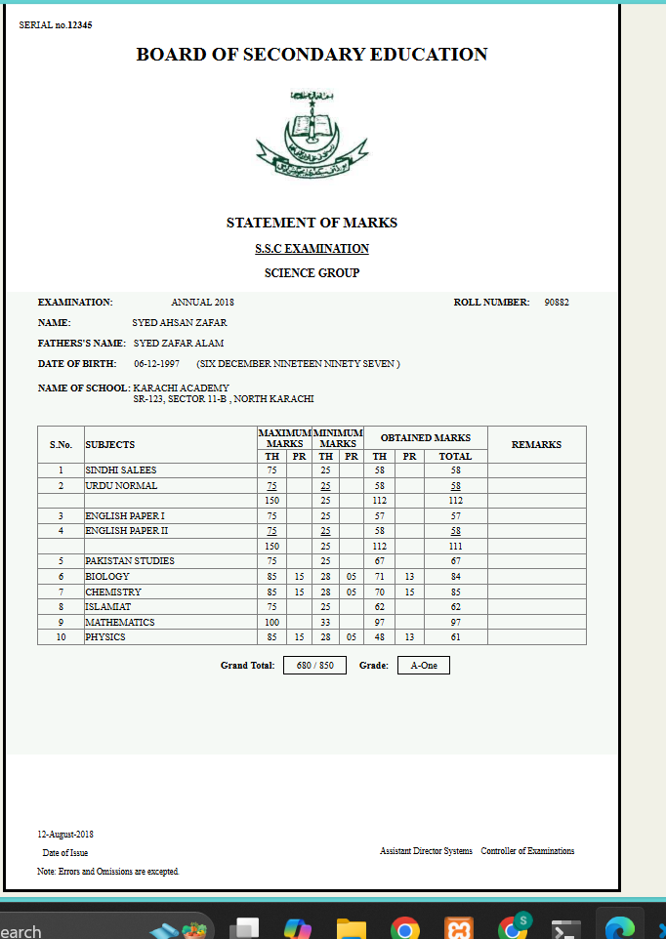

Intermediate marksheet
<!DOCTYPE html>
<html lang="en">
<head>
<meta charset="UTF-8">
<meta name="viewport" content="width=device-width, initial-scale=1.0">
<title>Statement of Marks</title>
<link rel="stylesheet" href="INTER.CSS">
</head>
<body>
<div class="container">
<div class="header">
<div class="doc-number">900786</div>

<div class="logo">
<span><img src="board-of-intermediate-education-karachi-logo-png_seeklogo-611903.png" height="100px" alt="biek logo"></span>
</div>

<h1 class="board-name"><u>BOARD OF INTERMEDIATE EDUCATION KARACHI</u></h1>
<p class="exam-info">H.S.C PART - I & II INTERMEDIATE EXAMINATION (Annual - 2021)</p>
<h2 class="statement-title"><u>Statement of Marks</u></h2>
</div>

<div class="info-section">
<div class="info-row">
<span class="info-label">Marks Sheet No.</span>
<span class="info-value">10234561-0</span>
</div>
<div class="info-row">
<span class="info-label">Group</span>
<span class="info-value">PRE-ENGINEERING</span>
</div>
<div class="info-row">
<span class="info-label">Roll No.</span>
<span class="info-value">921550</span>
</div>
<div class="info-row">
<span class="info-label">Enrolment /Registration No</span>
<span class="info-value">CNN1/SE/E-0300/2020</span>
</div>
<div class="info-row">
<span class="info-label">Name</span>
<span class="info-value">SYED AHSAN ZAFAR</span>
</div>
<div class="info-row">
<span class="info-label">Father's Name</span>
<span class="info-value">SYED ZAFAR ALAM</span>
</div>
<div class="info-row">
<span class="info-label">College / Private</span>
<span class="info-value">GOVT. COLLEGE FOR MEN NAZIMABAD</span>
</div>

<table class="marks-table" border="1">
<thead>
<tr>
<th rowspan="3" >Subject</th>
<th colspan="4">Part I Marks</th>
<th colspan="4">Part II Marks</th>
<th colspan="4">Combined</th>
<th rowspan="3">%</th>
<th rowspan="3">Remarks</th>
</tr>
<tr>
<th colspan="2">Max.</th>
<th colspan="2">Secured</th>
<th colspan="2">Max.</th>
<th colspan="2">Secured</th>
<th colspan="2">Max.</th>
<th colspan="2">Secured</th>
</tr>
<tr>
<th>Th</th>
<th>Pr</th>
<th>Th</th>
<th>Pr</th>
<th>Th</th>
<th>Pr</th>
<th>Th</th>
<th>Pr</th>
<th>Th</th>
<th>Pr</th>
<th>Th</th>
<th>Pr</th>
</tr>
</thead>
<tbody>
<tr>
<td class="subject-col">URDU NORMAL</td>
<td>100</td>
<td>-</td>
<td>52</td>
<td>-</td>
<td>100</td>
<td>-</td>
<td>52</td>
<td>-</td>
<td>200</td>
<td>-</td>
<td>104</td>
<td>-</td>
<td>52</td>
<td class="pass">Pass</td>
</tr>
<tr>
<td class="subject-col">ENGLISH NORMAL</td>
<td>100</td>
<td>-</td>
<td>52</td>
<td>-</td>
<td>100</td>
<td>-</td>
<td>52</td>
<td>-</td>
<td>200</td>
<td>-</td>
<td>104</td>
<td>-</td>
<td>52</td>
<td class="pass">Pass</td>
</tr>
<tr>
<td class="subject-col">ISLAMIC EDUCATION</td>
<td>50</td>
<td>-</td>
<td>26</td>
<td>-</td>
<td>-</td>
<td>-</td>
<td>-</td>
<td>-</td>
<td>50</td>
<td>-</td>
<td>26</td>
<td>-</td>
<td>52</td>
<td class="pass">Pass</td>
</tr>
<tr>
<td class="subject-col">PAKISTAN STUDIES</td>
<td>-</td>
<td>-</td>
<td>-</td>
<td>-</td>
<td>50</td>
<td>-</td>
<td>26</td>
<td>-</td>
<td>50</td>
<td>-</td>
<td>26</td>
<td>-</td>
<td>52</td>
<td class="pass">Pass</td>
</tr>
<tr>
<td class="subject-col">CHEMISTRY</td>
<td>85</td>
<td>15</td>
<td>44</td>
<td>8</td>
<td>85</td>
<td>15</td>
<td>29</td>
<td>13</td>
<td>170</td>
<td>30</td>
<td>73</td>
<td>21</td>
<td>47</td>
<td class="pass">Pass</td>
</tr>
<tr>
<td class="subject-col">PHYSICS</td>
<td>85</td>
<td>15</td>
<td>44</td>
<td>8</td>
<td>85</td>
<td>15</td>
<td>42</td>
<td>14</td>
<td>170</td>
<td>30</td>
<td>86</td>
<td>22</td>
<td>64</td>
<td class="pass">Pass</td>
</tr>
<tr>
<td class="subject-col">MATHEMATICS</td>
<td>100</td>
<td>-</td>
<td>52</td>
<td>-</td>
<td>100</td>
<td>-</td>
<td>51</td>
<td>-</td>
<td>200</td>
<td>-</td>
<td>103</td>
<td>-</td>
<td>51.5</td>
<td class="pass">Pass</td>
</tr>
<tr class="total-row">
<td class="subject-col"><b>Total</b></td>
<td colspan="2"><b>Max Marks I</b></td>
<td colspan="2"><b>Secured Marks I</b></td>
<td colspan="2"><b>Max Marks II</b></td>
<td colspan="2"><b>Secured Marks II</b></td>
<td colspan="2"><b>Total Max. Marks</b></td>
<td colspan="2"><b>Total Sec. Marks</b></td>
<td><b>Over All %</b></td>
<td><b>Grade</b></td>
</tr>
<tr class="total-row">
<td></td>
<td colspan="2"><b>550</b></td>
<td colspan="2"><b>286</b></td>
<td colspan="2"><b>550</b></td>
<td colspan="2"><b>279</b></td>
<td colspan="2"><b>1100</b></td>
<td colspan="2"><b>565</b></td>
<td><b>51.36</b></td>
<td class="grade"><b>C</b></td>
</tr>
<tr>
<td class="subject-col"><b>In Words</b></td>
<td colspan="14" style="text-align: center;"><b>Five Hundred Sixty Five Only</b></td>
</tr>
<tr>
<td class="subject-col"><b>Grace/Grade Raised</b></td>
<td colspan="14"></td>
</tr>
</tbody>
</table>

<div class="footer">
<div class="signature-section">
<div class="signature-box">

<div class="signature-label">PREPARED BY IT DEPARTMENT</div>
</div>

<div class="controller-section">

<div class="controller-label">CONTROLLER OF EXAMINATIONS</div>

<div class="date"></div>
</div>

</div>
</body>
</html>
